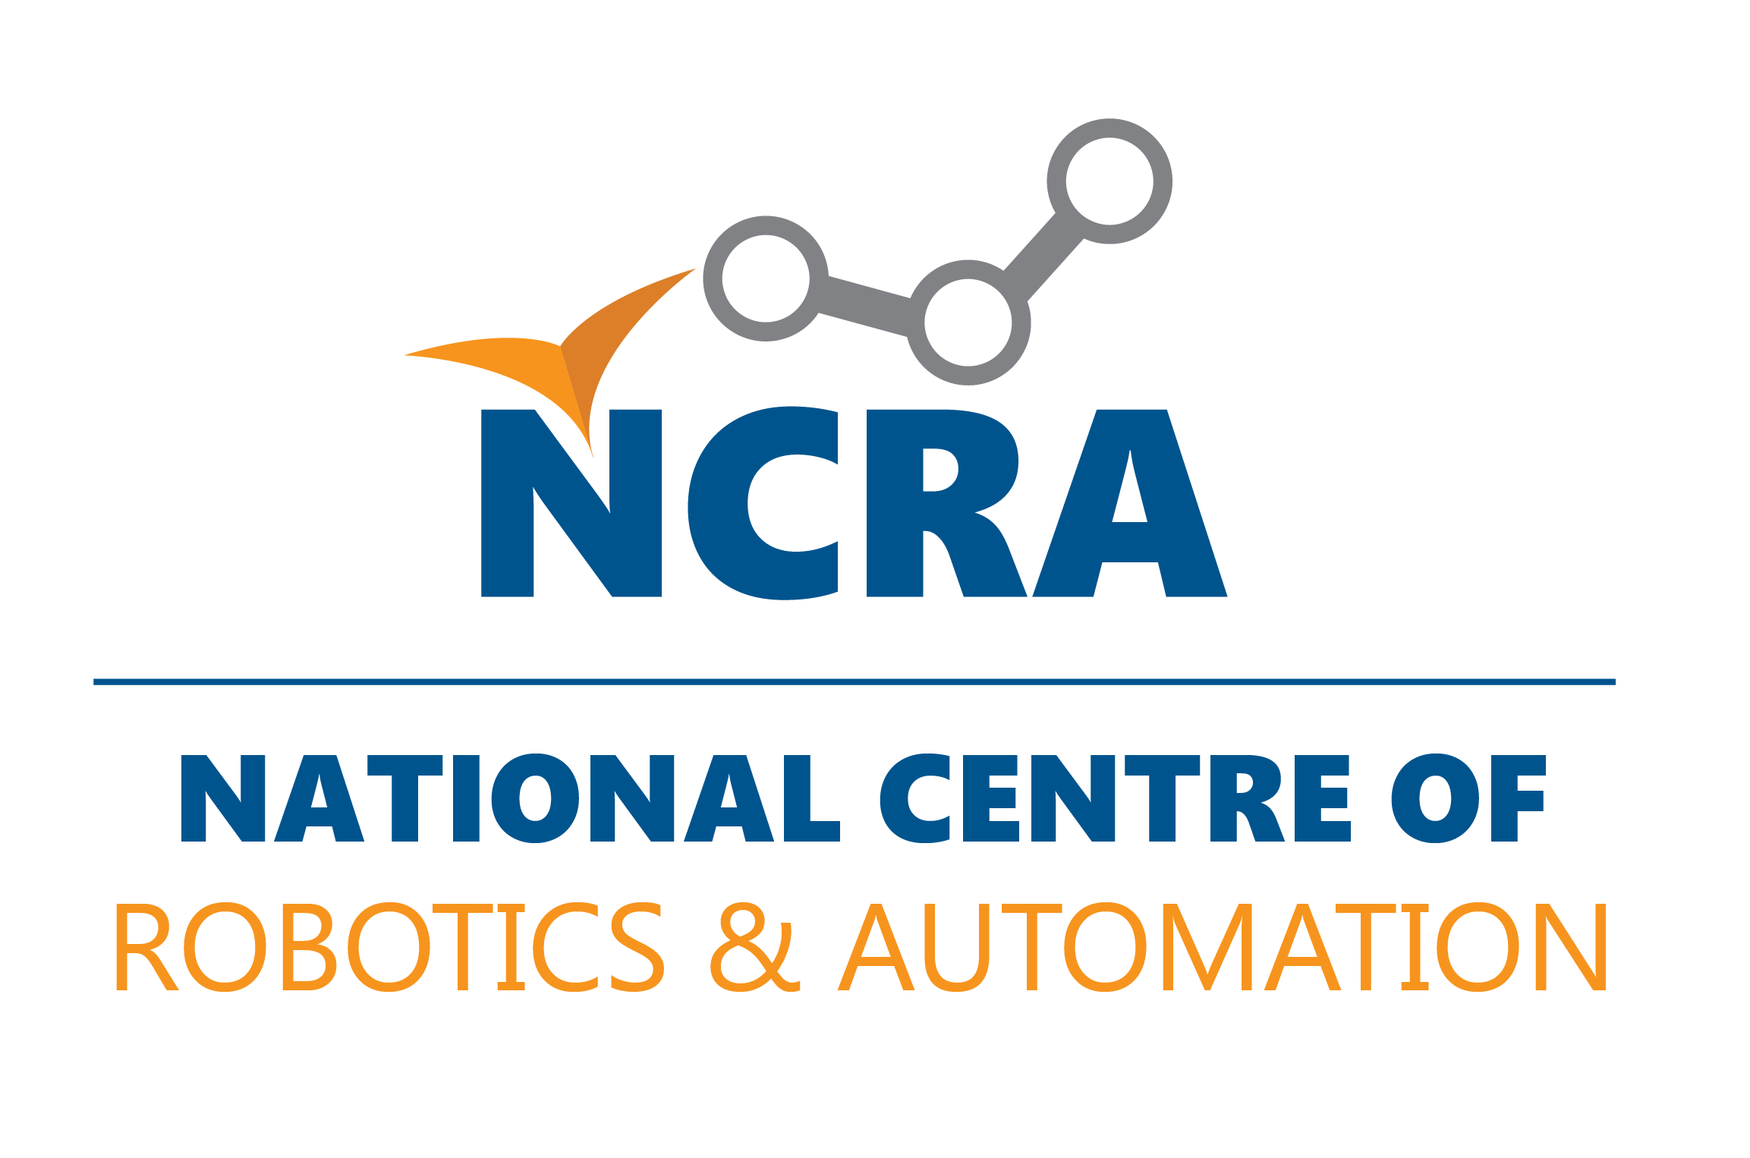
National Centre of Robotic and Automation

For NCRA use only
Proposal Identification Number

Research fund for

Prototype/Product Development grant proposal

COVER SHEET FOR PROPOSAL

A1. TITLE OF PROPOSED PROJECT

A2. CLASSIFICATION/NAME OF PRODUCT/PROCESS/SERVICE TO BE CREATED

A3. RELEVANCE OF THE PROJECT WITH THE DOMAIN OF ROBOTICS AND AUTOMATION (Up to 100 words)

A4. List of Contents:
S.N | Item Details | Page No

B1. RESEARCH DOMAIN
Product Development/ Improvement Process Development/ Improvement

B2. STATE FIELD OF RESEARCH AND SPECIALIZATION (For example; PREVIOUS EXPERIENCE WITH INDUSTRIAL RESEARCH)

Major/Specialization _______________________________ Relevant Industry _____________________________________

C1. PROJECT DIGEST. Describe the proposed PROJECT using about 250 words in easy business language.

C2. Patent/IP Search:
- What is the status of your idea vis-à-vis similar patents?

- Have you already filed a patent application?

- If a patent already exists on your idea/concept, then what is your strategy and rationale in commercializing the proposed research?

- Proof of funding i.e. award letter if prototype is developed or basic R&D is completed (National HEC, PSF, Ignite and or International, etc.). Please specify;

D. PRINCIPAL INVESTIGATOR (from University / Institution)
D1. PRINCIPAL INVESTIGATOR NAME (full with no initials) |  |  |  |  | D2. HIGHEST DEGREE |  |  | D3. POSITION
D4. DEPARTMENT/SECTION | D5. UNIVERSITY/INSTITUTION |  |  |  | D6. CNIC#  Please attach a  Paste or place JPEG passport size photograph  crossed copy
D7. Telephone:(area code, number and extension)
Mobile: Fax: (area code, number) :
Email:
Postal Address:

E: INDUSTRIAL PARTNER (from Collaborating Industry)
E1. Industrial Partner NAME (full with no initials) |  | E2. HIGHEST DEGREE |  |  |  | E3. POSITION
E4. SECTION / UNIT |  | E5. FACTORY / INDUSTRY |  |  |  | E6. OFFICIAL MAILING ADDRESS
E7.Partner Industry Certification/Registration:
NTN/STN:
E8. Telephone:( area code, number and extension) Fax: (Area code, number)
Mobile: Email:
F1. PROPOSED DURATION OF PROJECT: (in months) |  |  |  | F2. PROPOSED STARTING DATE
F3. TOTAL FUNDS REQUESTED  RS. |  | F3. NCRA COMPONENT (UPTO 14Million)  A. 1st YEAR RS.___ ___________________(Million)  B. 2nd YEAR  RS. _____________________ (Million) |  |  |  | F4- INUDSTRY COMPONENT  A. 1st YEAR RS.________________(Million)  B. 2nd YEAR  RS. _____________________ (Million)
SIGNATURE OF PRINCIPAL INVESTIGATOR  Date |  |  | SIGNATURE OF PARTNER INDUSTRY  Date

ENDORSEMENT OF THE HEAD OF INSTITUTION (Vice-chancellor/Rector of University, Director of Degree-awarding Institutions)  Signature & Date  Name Title:  Address:  Phone  FAX  E-mail | ENDORSEMENT OF THE HEAD OF INDUSTRIAL ORGANIZATION  (Must be stamped)  Signature & Date  Name Title:  Address:  Phone  FAX  E-mail

Project DEtails

1. PROJECT EXECUTIVE SUMMARY
Describe the proposed prototype and any research required using about 500 words. Attach sketch/diagrams/photo, if needed, to illustrate your concept.

2. PROPOSED GOALS/OBJECTIVES (please identify quantifiable goals)
Please clearly identify the output in the form of a product or process, need or relationship to industry and also identify other end-users of your output/product.

GOALS/OBJECTIVES (please quantify your objectives in case of Applied research)

1.

2.

3.

4.

5.

6.

7.

3. INTRODUCTION (not to exceed one page)
The introduction should consist of three paragraphs; the first paragraph should indicate the scientific and/or commercial basis on which the project is based. The second paragraph should introduce the precise nature of the project, and the final paragraph should indicate the proposed objectives in the light of the first two paragraphs and explain clearly what the reader will see in the main body of the proposal.

(PLEASE ATTACH ONE SHEET ONLY)

4A. BACKGROUND AND METHODOLOGY OF THE PROPOSED RESEARCH (Not to exceed two pages)
A comprehensive and up to-date justification for the proposed program for technology development, industrial growth, and contribution to national economy.

(PLEASE ATTACH TWO SHEETS ONLY)

4B. RESEARCH PLAN: SCHEDULE/PHASING (Preferably with a time/ GANTchart not to exceed one page)
(PLEASE ATTACH ONE SHEET ONLY)

4C. REFERENCES (cited in 3, 4A & 4B; not to exceed two pages)
(PLEASE ATTACH TWO SHEETS ONLY)

5. IMPACT
Impact of proposed prototype on aspects such as transfers of research results into the economy in order to implement innovation, effects on import substitution and/or export enhancement, and on technology-oriented human-resource development. Please also identify other end-users of the research results. E.g.

- Utilization of local raw materials
- Creation of Employment
- Utilizing current skill or creating new skills
- Impact on local manufacturing or service cluster; explain how these will be helpful to move the particular sector up the value chain.
- Solution to current local problems.
- Reverse Engineering (adaptive research) from creation of wealth.
- Export potential and global market possibilities with impact on local job creation. You may gather trade statistics from http://www.trademap.org/

6. Sustainable Development Goals (SDG’s) (How and which of the SDG’s will be addressed in this study? Justify how the proposed research will contribute to achieve SDG’s of Pakistan. For details on SDG’s /s please visit:)

http://undocs.org/A/68/970

http://www.un.org/sustainabledevelopment/sustainable-development-goals

http://www.slideshare.net/derekschwabe/the-17-proposed-sustainable-development-goals

7. PROJECT PARTNERS (information on Industry)
Please give a brief introduction of the collaborating industry, especially information on turnover, import/export profile, stock exchange listing etc. Please indicate the portion of the proposed research program to be carried out at the Partners organization. Also state that how and where the Partner’s budgetary contribution will be utilized.

8. PROJECT Business Plan/Work plan (Attach the Business Plan for your proposed project)
Please provide an overview of your Business plan to include activities taking place.

Please also provide financial analysis, market value and how the proposed product/process will do business?

9. PROJECT OUTPUT
Please give a brief account of expected output

10. FACILITIES AND FUNDING
10A. Facilities: equipment available for the research project IN THE HOST UNIVERSITY/INSTITUTION & THE COLLABORATING OGRANIZATION

10B. Scientific Personnel (at the PI institution)

- Available

- Required*

*Involvement of research students is encouraged.
10C. Other funding available for the proposed studies (if any)

11A. PRINCIPAL INVESTIGATOR
A brief resume of research accomplished in the last 05 years. Please specify title of the research proposal(s), duration, funding source(s) and award amount(s). Detailed CV can be placed as annex at the end.

- Please attach C.V.
2. Number of Publications during the last five years & page National: _________ Please see pages___________ of CV
numbers on the C.V. where these publications are listed International: _______ Please see pages : __________ of CV
3. Number of research projects completed & page number Basic: _________ Please see pages ___________ of CV
where this information appears Applied: _______ Please see pages___________ of CV

11B. Industrial Partner (Profile of Partner industry, Accreditation and Certification, Website, Focal Person Contacts. Email, mobile and landline)
A brief Profile highlighting achievements / experience especially concerned with the present proposal. Detailed CV of focal person can be placed as annex at the end.

11C. CO-PRINCIPAL INVESTIGATOR
A brief resume highlighting achievements/ experience especially concerned with the present proposal. Detailed CV can be placed as annex at the end.

12A. ESTIMATED BUDGET FOR THE PROPOSED RESEARCH PERIOD (Rs. in million, please avoid simple calculations)
NCRA will fund up to Rs. 15 Million and there is no limit for Industry but proposals with industrial financial assistance will be preferred.
Please submit M.S. Excel sheet separately.
DESCRIPTION | YEAR 1 |  | YEAR 2 |  | Total Amount
 | NCRA | Industry | NCRA | Industry | NCRA | Industry
A. Salaries and Honorarium
PI: according to percentage of time allocated for project @
Academic Co-PI: according to percentage of time allocated for project @
Patent filing
Subtotal:
Prototype Development Cost
B. Permanent Equipment (Please attach invoice/quotation and expected delivery date for items costing over Rs 0.1 Million)
Subtotal:

C. Expendable Supplies
Subtotal:

12A. ESTIMATED BUDGET FOR THE PROPOSED RESEARCH PERIOD (Rs. In million)-continued
DESCRIPTION | YEAR 1 |  | YEAR 2 |  | Total Amount
 | NCRA | Industry | NCRA | Industry | NCRA | Industry
D. Others
D1. Literature ; documentation, information, online literature search, contingencies, postage, etc.
Subtotal:

D2. Local Travel (Destination and Purpose)
Subtotal:

D3. Miscellaneous
Subtotal:
Subtotal (D1 + D2 + D3):
E. Indirect cost (University overheads)  A. If ORIC notified by HEC: 15% of Total direct costs to the university to provide office support, utilities, etc.)  B. If ORIC is not notified by HEC: 2% of total direct cost to the university to provide office support, utilities, etc.) |  | Nil |  | Nil |  | Nil
Grand Total (NCRA 1st year A + B + C + D + E) visa versa:
Please make sure calculations will be correct.
Total Budget | NCRA:  1st +2nd year |  | Industry:  1st +2nd year |  | Total:  NCRA + Industry Components

13. JUSTIFICATION (Please justify your request in a background of the existing facilities available at the host Institute.)
A. Salaries & Allowances (All positions, other than PI and industrial partner, must be fully justified. Please give qualifications/requirements/ brief Job Description of each of the new full-time positions requested for in the Proposal.)

B. Permanent Equipment (Please identify major items (over Rs. 25,000). Major pieces of equipment costing over Rs. 0.1 million must be fully justified. Minor items (under Rs. 25,000) may be lumped into one.)

C. Expendable supplies

D. Other Costs. (Travel must be justified.)

14.
(A) Enlist Three Academic Evaluators/Experts from Higher Education Institutions/R&D organizations/Universities (Name, Mobile number, postal and email address information)
1.
2.
3.
(B) Enlist Two Industrial Evaluators/Experts from Industry/Government and Private R&D organizations (Name, Mobile number, postal and email address information)

1.
2.

_____________________________

Signature Principal Applicant Date:

- Check list:

Make sure the following must accompany the application otherwise proposal will not be shortlisted.

Sr. No. | Requirement | Y/N
1 | Application must be routed through University ORIC or Directorate of Research
2 | CNIC copy of Principle Investigator
3 | Passport size photograph
4 | Industrial Support letter from partner industry
5 | Partner Industry NTN/STN provided
6 | Industrial Partner certification (Registration, ISO or any other etc.)
7 | Mobile/cell phone number and personnel & official email of project team
8 | Authentication from Head of the institution and submission through ORIC
9 | Authentication from Head of the industry not necessary on the form (a separate letter on industrial letter pad will serve the purpose properly addressed to head of university/institution)
10 | CV of PI
11 | CV of Co PI
12 | Profile of Industrial Partner
13 | Quotations of the equipment & Supplies (if cost is more than PKRs.0.1 million)
14 | Project Key Performance indicators against which performance will be evaluated
15 | Budget should also be submitted on prescribed M.S excel sheet sent with soft copy
16 | Research Fund-Proposal information sheet on prescribed M.S excel sheet sent with soft copy
17 | All documents must be in one application file
18 | Application package must have M.S world file, PDF, Budget & Information sheet (excel)
19 | 3 hard copies with proper Tape binding (no spiral binding will be accepted)
20 | - After online submission a soft copy of documents must be emailed to research@ncra.org.pk
21 | Subject your e-mail submissions as (NCRA-PI Name-University Name Abbreviation) i.e. (NCRA-Qasim Altaf-NUST)
22 | Online submission and email submission to be done before the deadline (15th July 2020).

- CNIC & Photograph of PI

- Industry Support Letter

- Key Performance Indicators

- CV of PI (Brief) with web link to detailed

- CV of CO-PI (Brief) with web link to detailed

- Profile of Industrial Partner

- Quotations

